Medicoir – The professional growing media for cannabis growers
Medicoir is a professional standard growing media designed by experts in coir manufacturing. With over a decade of producing exceptional quality coir products for the commercial agriculture industry, the producers of Medicoir have the experience and knowledge needed to manufacture the best coir fiber blend for the cannabis industry.

Medicoir provides a mix of carefully chosen coir particle sizes that can offer an ideal environment in terms of drainage and water holding capacity for young plants to get the best start.

+ Medicoir gives the grower ease of control when managing the crop

+ Naturally forgiving when over irrigation may occur

+ Unwanted salts removed during production and elevated levels of calcium promote healthy root growth

+ Delivered in de-hydrated form providing ease of transport, storage and set up

+ Manufactured in an eco-friendly, sustainable and socially responsible manner, certified to international standards.

+ Available in the form of grow cubes, open top containers, layflat bags and bulk bales

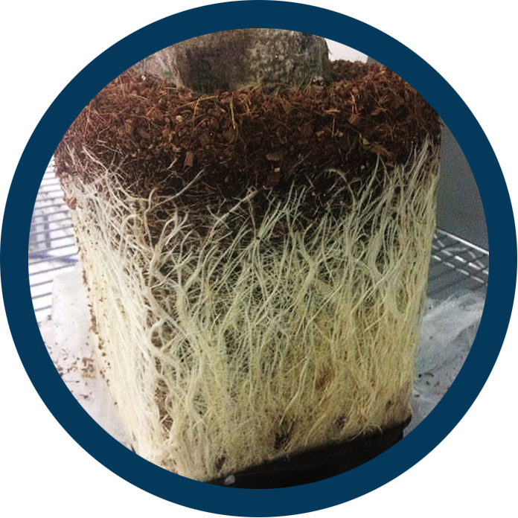

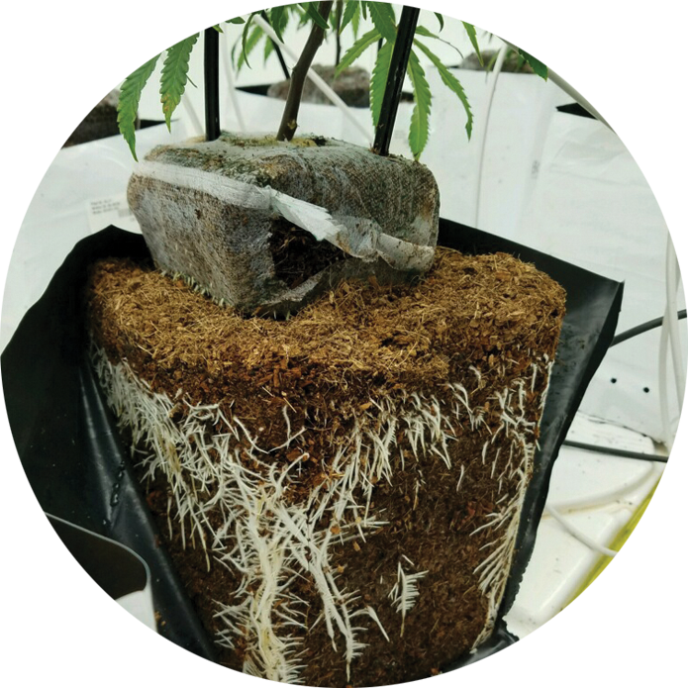

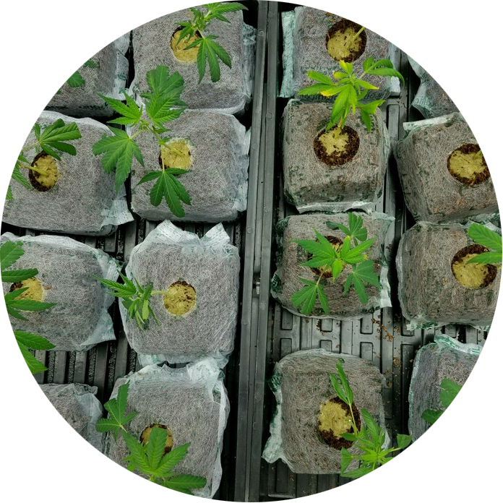

‘The best coir fiber blend for the cannabis industry.’

Only Sold in New Zealand
by
Harfords (2015) Ltd
03 385 5150

